­

**STOKBOX ANALYTICS**

YOUR PRODUCTS… OUR INSIGHT

# Table of Contents

Contents

Table of Contents 2

Introduction 3

Landing Page 3

User Features 4

Login Page 4

Dashboard Page 5

Forgot Password Form 6

Brand Page 8

Navigation Bar 9

Admin Features 10

Import Product Data Page 10

Import Consumer Data Page 10

Create New Users Page 11

First Time Logging In 12

View Imported Product Data 13

Managing Users 15

Dashboard 18

My Personas 20

Dark Mode 21

# Introduction

Welcome to Stokbox Analytics. This is a platform that allows your company to view and generate personas of customers.

From this, you can then be provided with information about the audience that are likely to purchase a given product.

Our platform allows you to query our database using filters and searches (narrowing it down to a specific product or group of products). Our database contains lots of information about thousands of products sold in UK supermarkets.

The database then queries another database containing user data which is used by our algorithm to generate your persona.

All data can then be found on your user dashboard.

We understand navigating a new platform can be daunting, which is why we have created this simple interface that guides you through the process. Let us show you how to get started and get set up with our website...

# Landing Page

The landing page can be found by pressing “Home” from the top navigation bar by using the link:

http//www.stokbox.co.uk/landing. Once you have navigated there, you should see the following page:

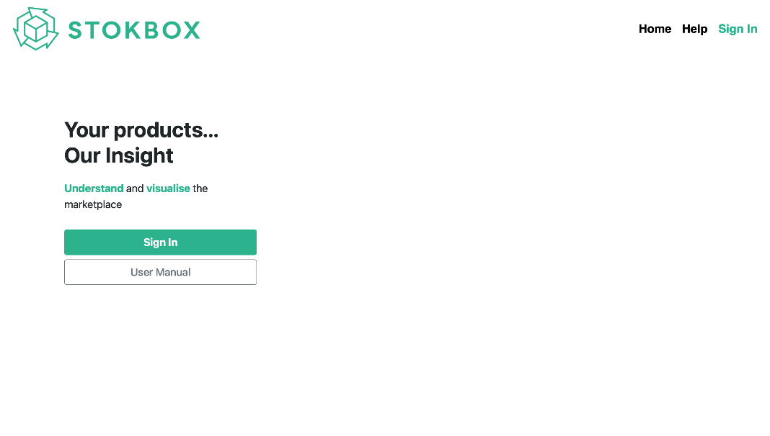

This page serves as a gateway to allow users who are not logged in to access certain areas of our website.

Specifically, this allows you to navigate to three areas:

Home - This will redirect you to the same page.

Help - This is where you are currently viewing this help notice.

Sign In - This take you to our login page, where you can sign in and access more areas of our website.

# User Features

## Login Page

From the landing page, press sign in to navigate to the landing page…

Enter your credentials into the box provided and press Log in… If you put the wrong credentials in, you’ll get a message telling you so…

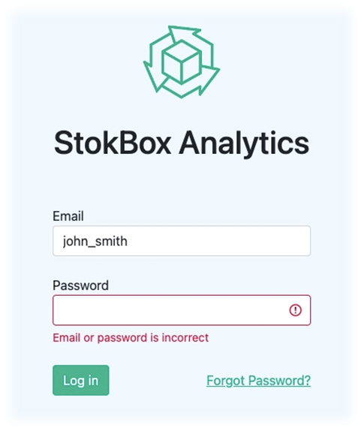

## Dashboard Page

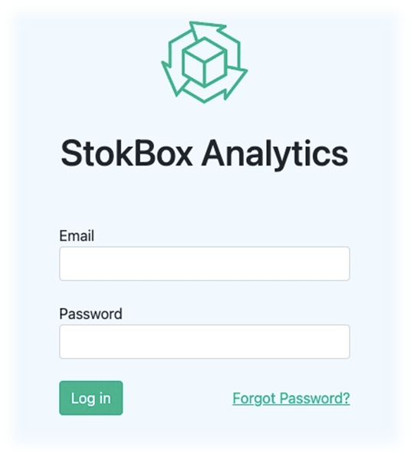Once logged in, you can see your dashboard…

At a glance, you can see all analytics relevant to your company and queries…

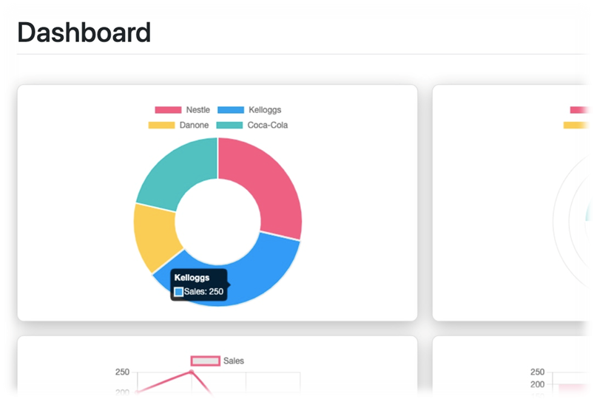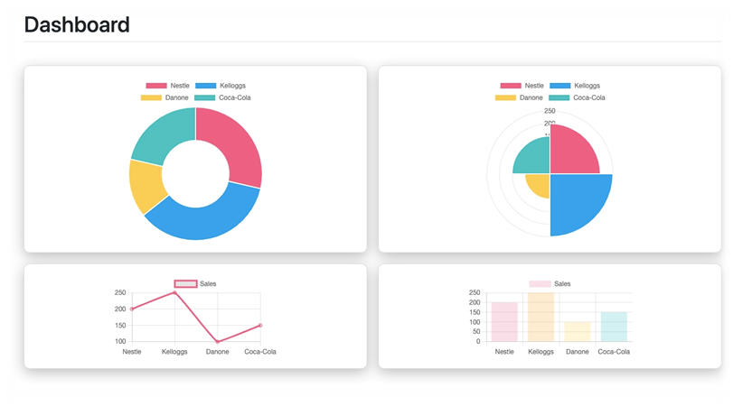

## Forgot Password Form

If you forgot password, it’s no problem

Simply click forgot password…

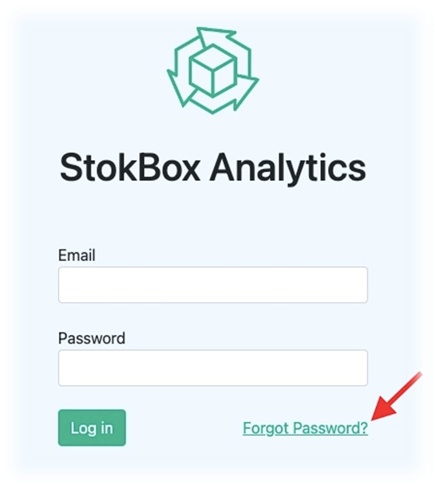

…enter your email address…

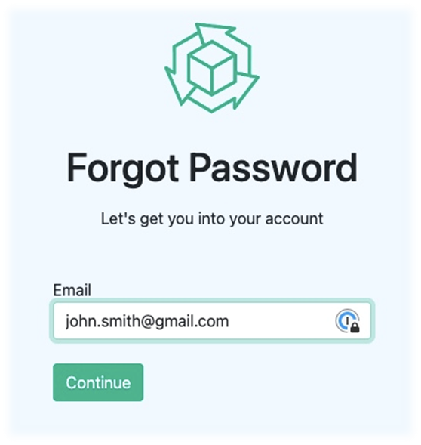

…and you’ll be sent a recovery email

## Brand Page

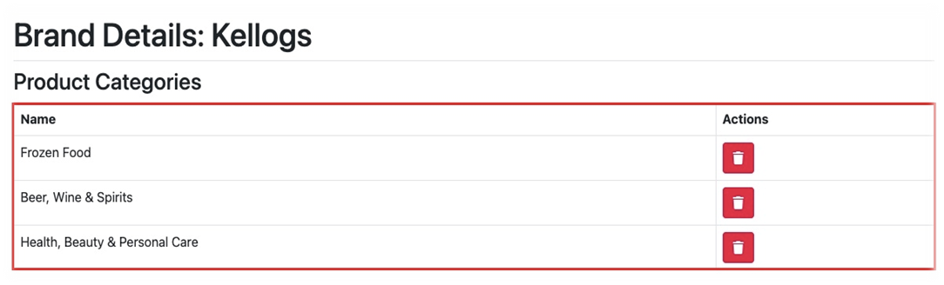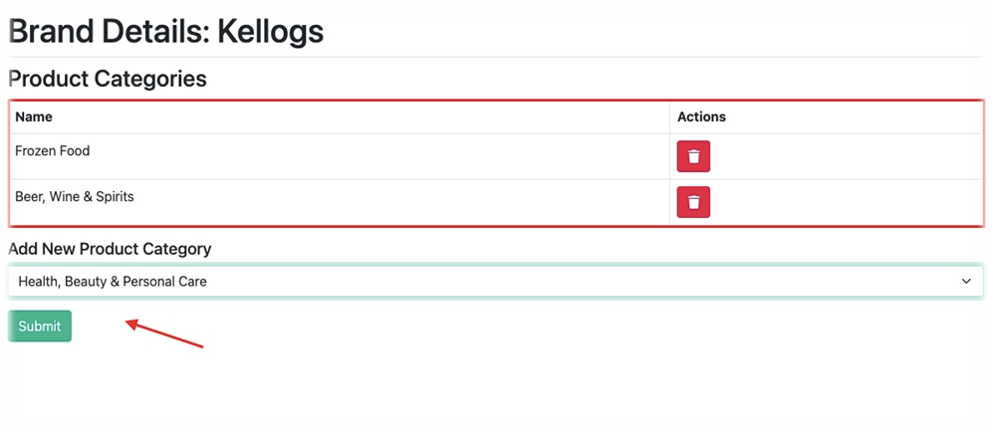You can customize the data we present by adding categories to your brand page… Simply select and Submit a new category. It’ll be added and stored to your brand page.

## Navigation Bar

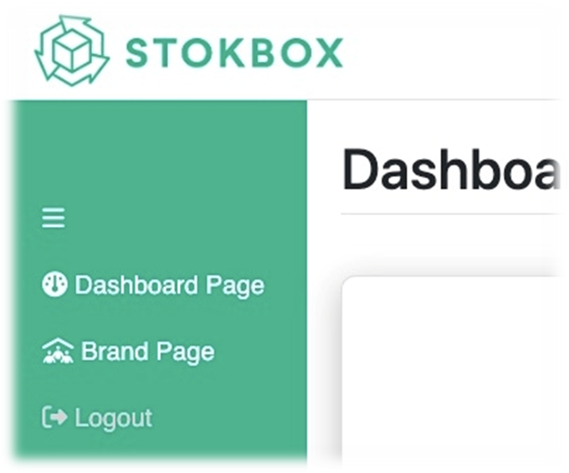You can move around the various features of the webapp by using the navigation bar

# Admin Features

## Import Product Data Page

An admin can update the database by uploading a new CSV Simply choose a new file, in the relevant formats and in the correct order…

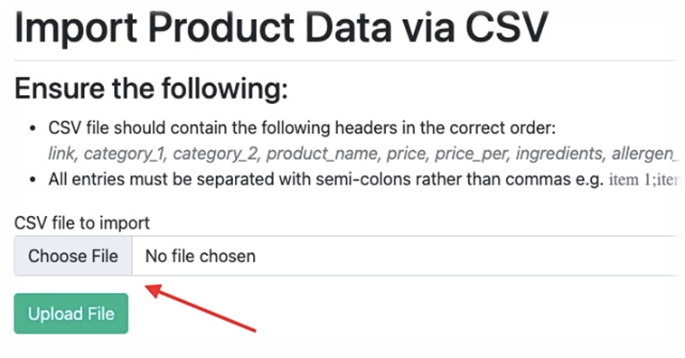*link, category_1, category_2, product_name, price, price_per_ingredients, allergen_information, brand recycling_information*

## Import Consumer Data Page

An admin can update the consumer database by uploading a new CSV

Simply choose a new file, in the relevant formats and in the correct headings

## Create New Users Page

An admin can add a new user… Simply select and add what company they are part of and submit it… Then input your user details

## First Time Logging In

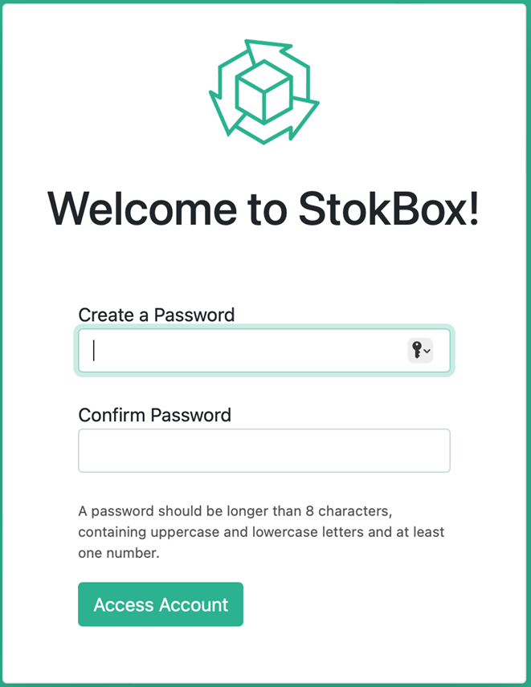The first time you log into StokBox Analytics, you will be prompted to create your password…

As shown, you have to validate your password by keeping it longer than 8 characters, containing uppercase and lowercase letters and at least one number. You also have to input your password twice - to ensure users don’t incorrectly spell it. The password is also hidden from view.

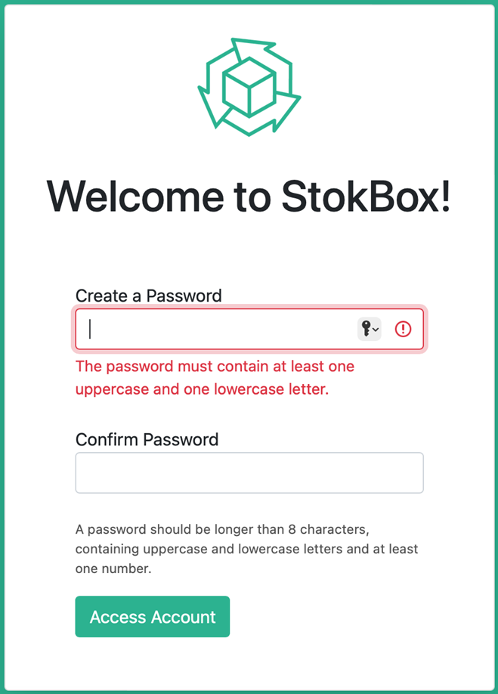If a user doesn’t follow the validation rules, the following validation will show:

## View Imported Product Data

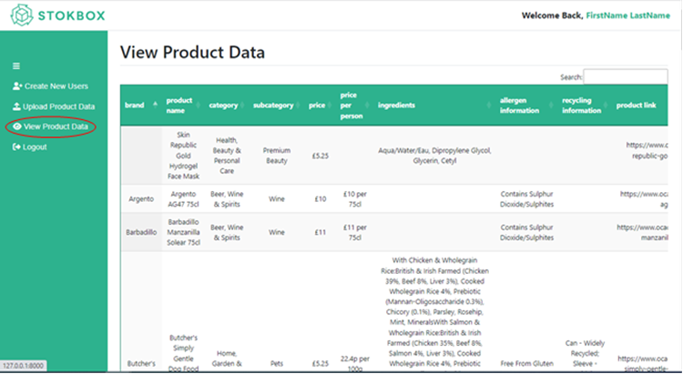As a website admin, I want to be able to view currently imported product data, so that I can check what data has been previously uploaded without having to query the database manually.

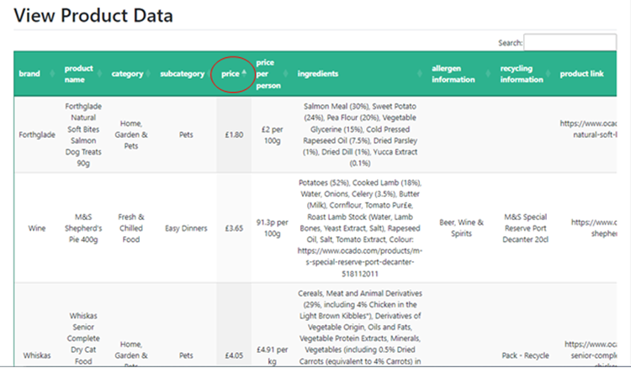The website admin can sort data by its value by clicking the name of the column, an example is shown as the user sorts the data by price, ascending.

The website admin can search for specific date from the table, an example of this is shown below, where sulphur is searched from the allergen information column.

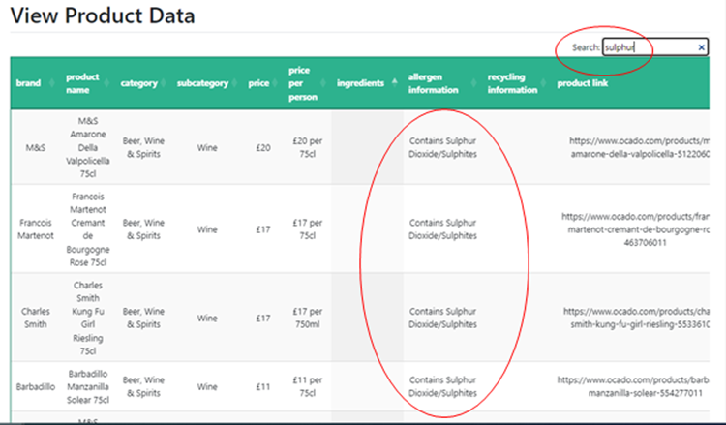

## Managing Users

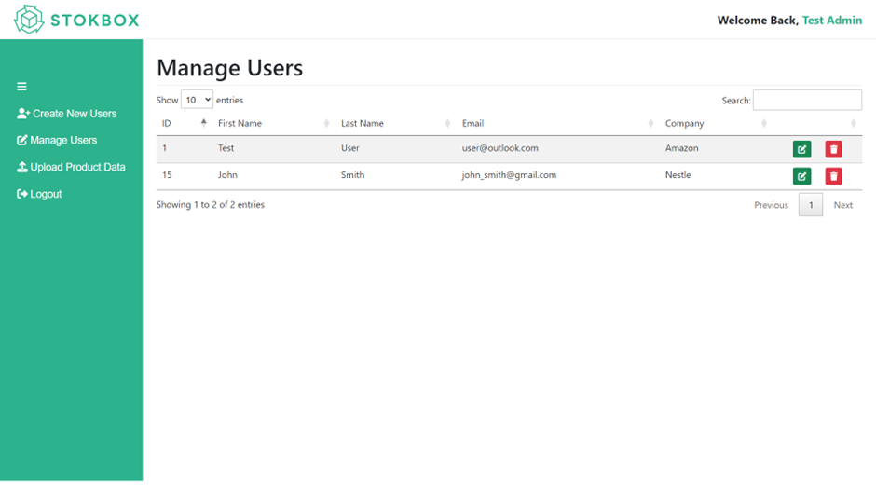An admin can view the current the current users in the database by navigating to the ‘Manage Users’ page. From here, an admin can decide to edit a user’s data or delete it entirely from the database.

Clicking the Edit button redirects you to the ‘Edit User’ page for that specific user, where you can edit the user’s details.

The form contains the user’s old information. The admin can redirect back to the ‘Manage Users’ page by clicking the cancel button. No changes will be made.

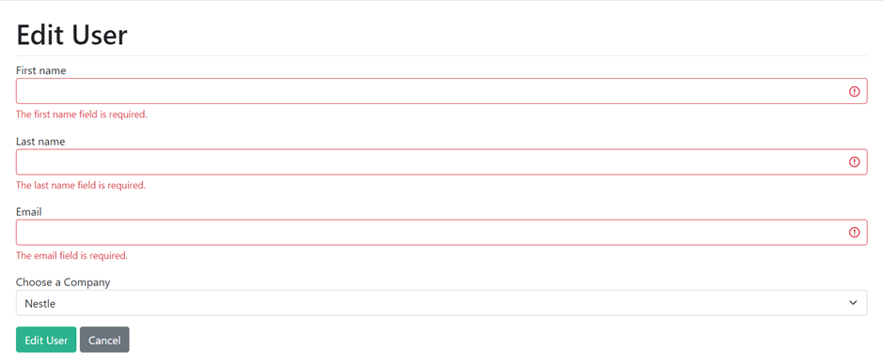Validation is applied to the form.

If the admin clicks the ‘Edit User’ button whilst no changes have been made, a warning alert will appear notifying the admin of this.

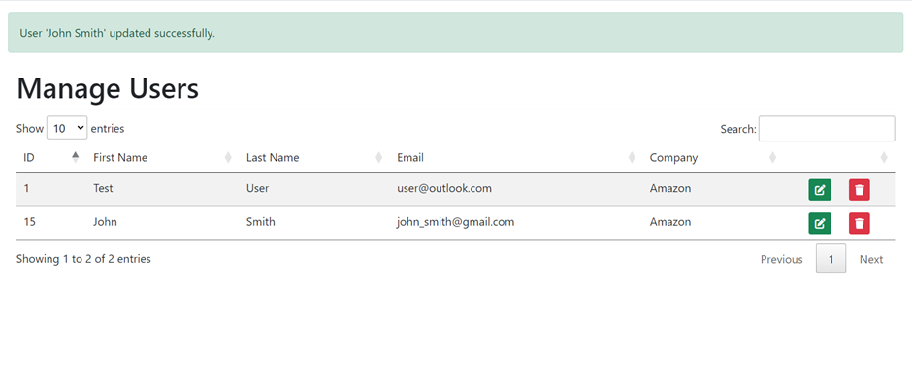Clicking the delete button completely deletes the user from the database.When the user is successfully edited, the admin is redirected to the ‘Manage Users’ page with a success alert, informing the admin of the successful action and which user it was applied to.

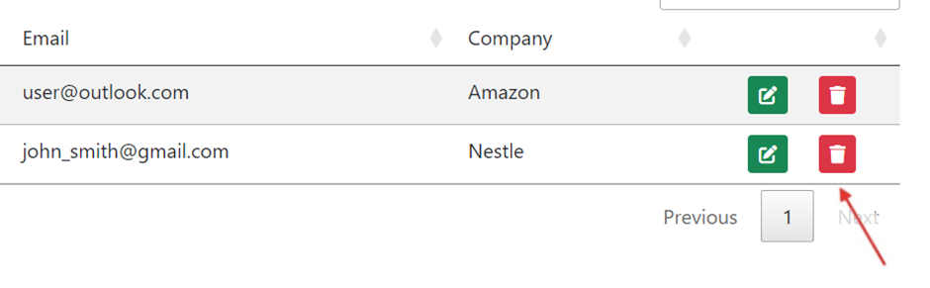Clicking the delete button completely deletes the user from the database.

The user will no longer appear on the table and the admin will be notified of the action through a danger alert.

# Dashboard

The dashboard displays all kinds of information about your consumers such as, gender, age, city, income, number of dependants and dietary requirements:

Use the filters tab at the top to filter the data in any way you want.

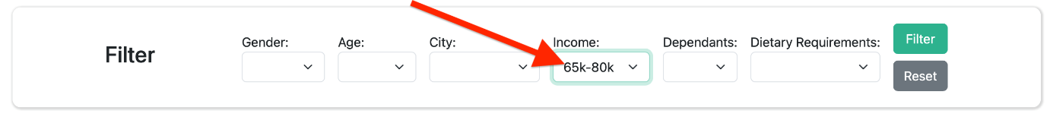

## My Personas

You can view your personas on the personas page. This looks like so...

You can also view each personas individual profile.

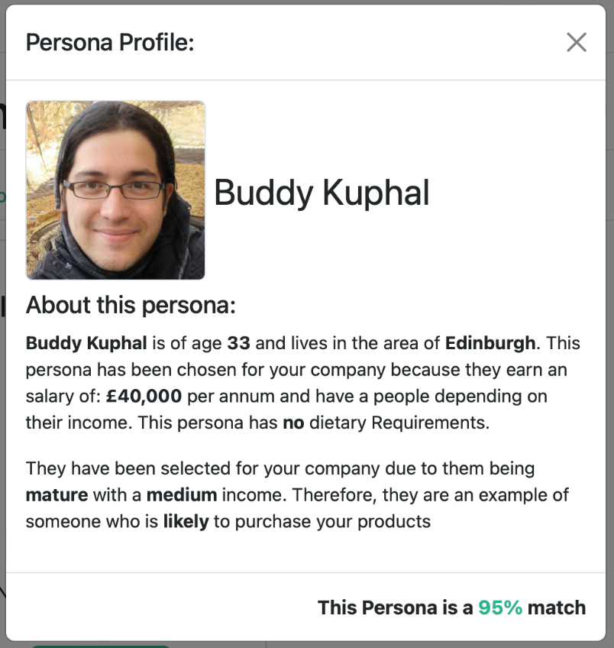

## Dark Mode

The site has a dark mode feature, which can be toggled by using the icon on the top right of all the pages (excluding the login pages).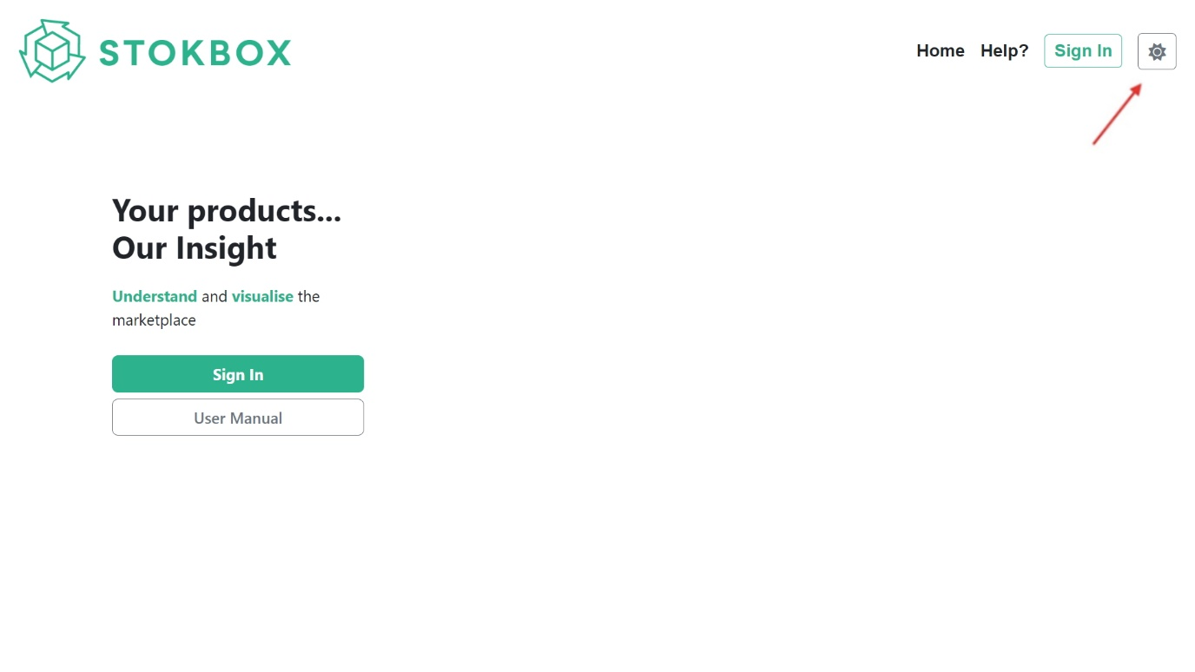

Clicking the button results in the dark mode theme as seen below.

